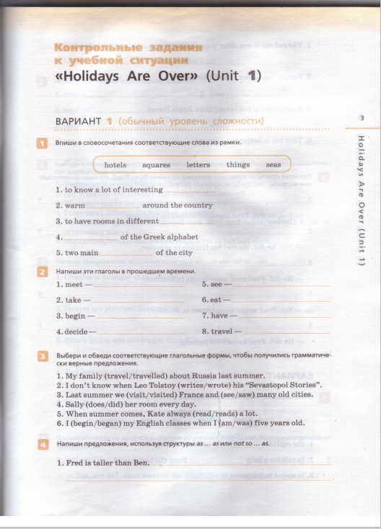

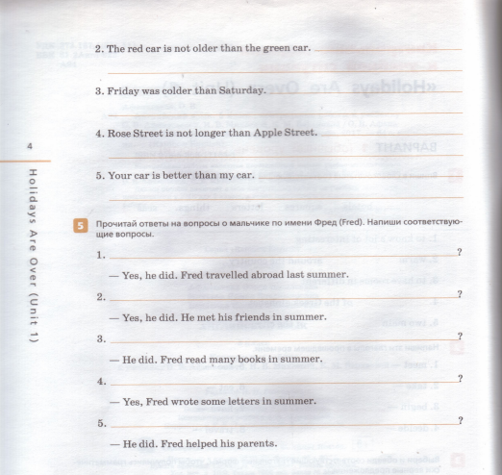
25-23 | 5
22-18 | 4
17-10 | 3
9> | 2

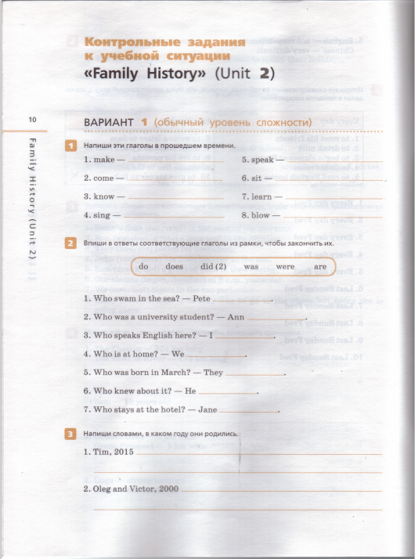

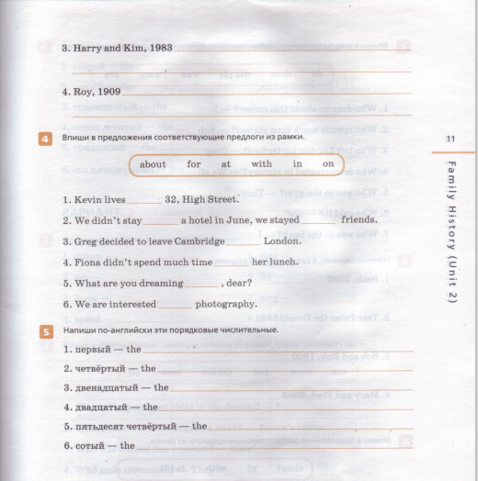

31-28 | 5
27-22 | 4
21-12 | 3
11> | 2

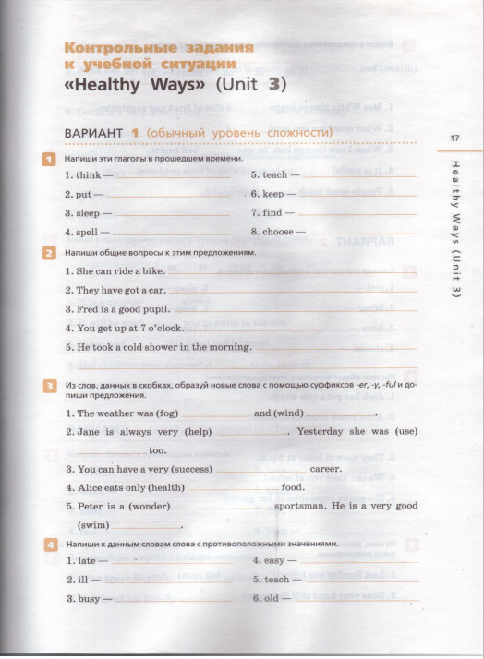

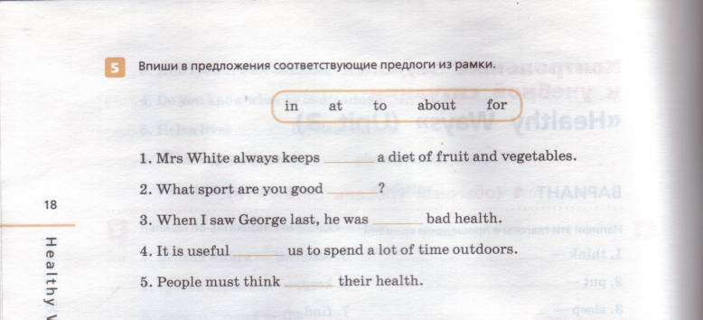

29-26 | 5
25-20 | 4
19-12 | 3
11> | 2

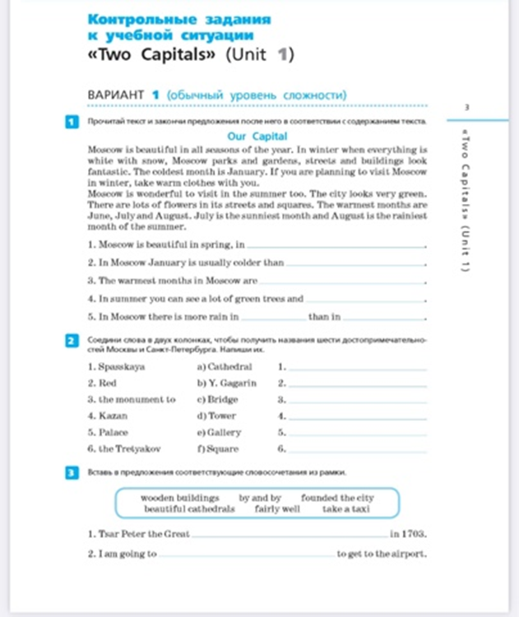

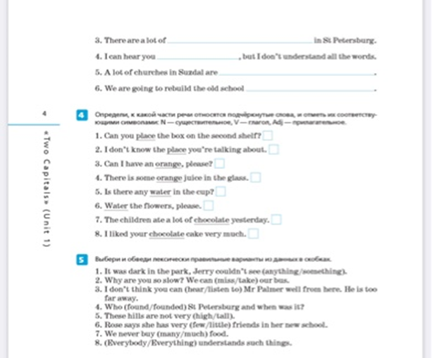

33-30 | 5
29-23 | 4
22-13 | 3
12> | 2

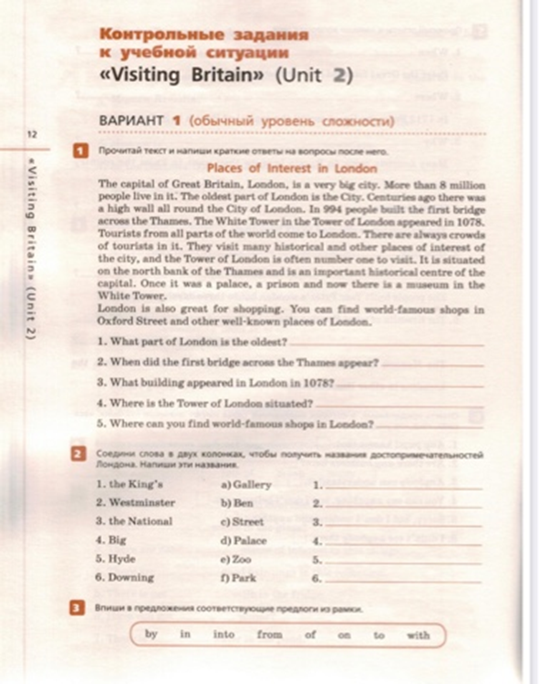

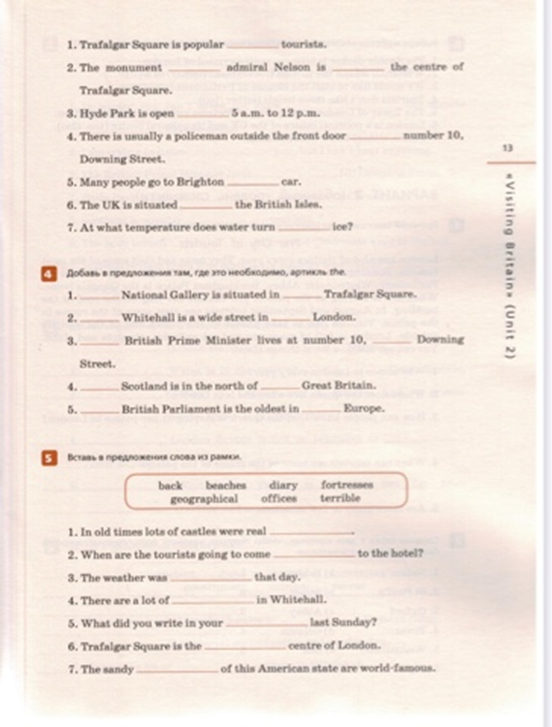
30-27 | 5
26-21 | 4
20-12 | 3
11> | 2

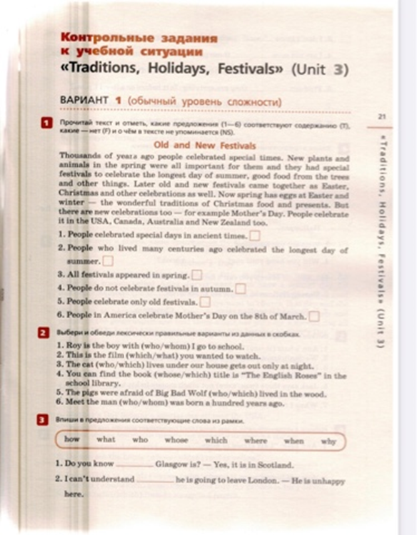

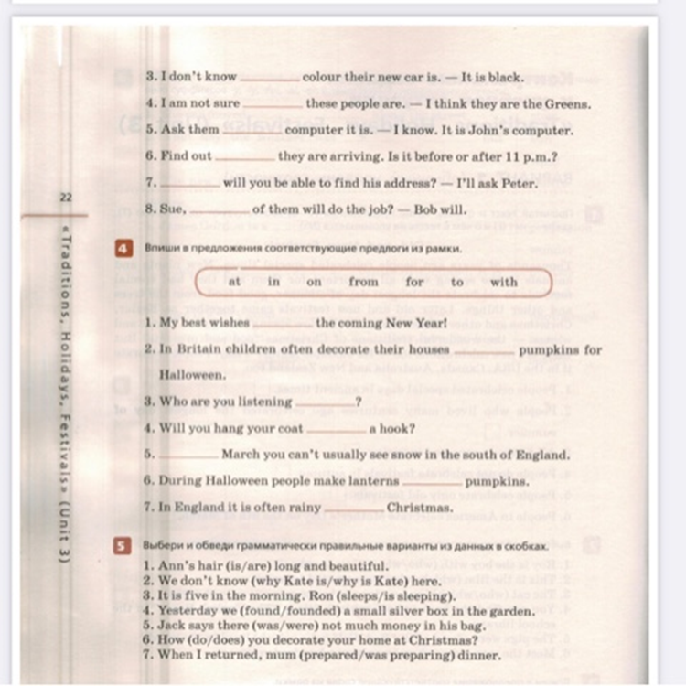
34-31 | 5
30-24 | 4
23-14 | 3
13> | 2

Rainbow English 7
Test 1
1. Прочитай текст и напиши, верны предложения (T) или нет (F):
In some areas of England there are schools for children under 5 years of age. Some boys and girls from two to five go there. Many parents organise informal playgroups for their children to keep them busy form 9 a.m. till 4 p.m. While parents are at work or busy in the house, children in these groups play, have lunch and sleep. Parents usually pay to keep their children in such groups, schools, or classes.
Primary education begins at the age of 5. Classes are not very long – about 20 minutes. Boys and girls have classes of reading, writing, and arithmetic.
- Children who are not 5 years of age have classes of reading, writing, and arithmetic.
- Playgrounds are usually free.
- Some parents send their children to playgroups.
- Primary education in England begins before children become 5.
- In primary schools teachers give their pupils classes of writing and reading.
- Classes in English primary schools are fairly long.
2. Переведи на английский язык:
- пара туфель 4) пара варежек
- пара ботинок 5) пара перчаток
- пара ножниц 6) пара носков
3. Впиши соответствующие служебные слова из рамки в предложения:
at during in into for of over to

- In Russia many boys and girls start primary education _____ the age of 6 or 7.
- What do you usually do _____ you long break?
- When is your last class usually _____, before or after 3?
- Talk Andrew _____ wearing the uniform. He looks good in it.
- We are _____ the seventh year.
- In state schools parents don’t have to pay _____ their children’s education.
- I don’t know what happened _____ them.

- We are proud _____ your success. You are the best chess player I know.
- know.
4. Используй суффиксы -an, -al, -er, -ful, -ly, -tion, -y и приставку un-, чтобы образовать новые слова, подходящие в данные предложения:
- Mr Green is not an Englishman, he is a _____. FOREIGN
- You shouldn’t speak _____ in class. LOUD
- My parents had a great holiday on the _____ SAND
beaches of California.
- The Mississippi is a very _____ river. POWER
- Sue’s a very _____ girl. MUSIC
- When did this _____ country appear? AFRICA
- I don’t think I like the _____s in this book. ILLUSTRATE

5. Выбери соответствующие варианты из данных в скобках:
- Victor is my (schoolboy / schoolmate). We go to school together.
- Linguistics (is / are) fairly difficult.
- Where are my pupils? There are very (few / little) schoolchildren in the classroom.
- I don’t want this drawing in the exercise book. Where is the (ruler / rubber)?
- Never talk (back / over) to your parents.
- Can you (tell / say) the time, please?
- Gerald and Andrew often (tell / talk) about sports.

6. Соедини реплики в микродиалогах. Запиши в тетрадь цифру и букву.

- Come in, please.
- Bob, I am asking you to read the text.
- You should do Exercises 10 and 11.
- Why were you absent yesterday?
- What’s the matter, Sue?
- Open your exercise books and write down the date.

- I couldn’t come to school, Miss, I was unwell.
- Shall I go to the blackboard?
- I’m sorry, I’m late.
- I’m sorry, I haven’t got my pen with me today.
- May I change my seat, please? I can’t hear well from here.
- Shall we do them at home?

40-36 | 5
35-28 | 4
27-16 | 3
15> | 2

Rainbow English 7
Test 2

1. Прочитате текст и напишите, утверждение верно (true), не верно (false) или об этом в тексте не сказано (not stated).

Today there are more than 3,000 languages in the world. Some of them are European languages. English is one of them.
You learn to speak when you are very young. You start learning a language even without knowing that you are learning anything. The language that you speak is the language you hear around you as you are growing up. It is usually the language your family and your friends speak. If you are born in an English-speaking family in the USA or Britain, you’ll probably start to speak English. If you are born in some other country, you are likely to learn the language of this country.

1) There are several thousand languages in the world.
2) You learn to speak when you are under five.
3) People usually speak the language their parents speak.
4) In the USA people speak different languages.
5) If you are not born in the USA, you probably cannot speak English.

2. Используйте суффиксы -ing, -er, -ful, -less, -tion, -ly и приставку un-, чтобы образовать новые слова.

6) The (OPERATE) has been successful, and now Andrew is much
better.
7) I couldn’t believe him: all his words were (TRUE).
8) I can’t sing this song. The melody is just (HATE).
9) We couldn’t say a word. We stood (SPEECH) looking at the young
performers.
10) I don’t think it is always easy to speak with (FOREIGN)s.
11) When was the (MEET) over?
12) The soldiers defended their country (BRAVE).

3. Поставьте глаголы в правильную форму.

13) Matilda has never (swim) in the sea.
14) Have you ever (read) detective stories?
15) My sister has (become) a famous architect.
16) Have you (borrow) the books from the library yet?
17) I have (ring) to Aunt Polly. Don’t you worry.
18) Everybody has (do) their jobs. We can have a break.
19) They have never (be) to Australia.

4. Выберите соответствующий вариант из данных в скобках.

20) Economics (is/are) a science.
21) In English state schools parents pay (for/of) some subjects.
22) Such (a/-) language is not easy to learn.
23) I haven’t been (to/in) Oxford yet.
24) Andrew developed (in/into) a real writer.
25) I don’t think slang words should be in our students’
(vocabulary/dictionary).
26) He doesn’t (even/ever) know that English as a language appeared
in the 5th century.
27) I have (ever/never) been to North America.
28) Have you seen Nelson’s Column (yet/already)?
29) Has Jenny (ever/never) used a bilingual dictionary?
30) Jason has (yet/already) met some people from Australia.

Разбалловка:
30 - 27 = 5
26 - 21 = 4
20 - 12 = 3
11 - 0 = 2

Unit 3 Test
1. Прочитай текст и отметь, какие утверждения после него соответствуют содержанию (true), а какие – не соответствуют (false).
The United States of America is a country whose 48 states are situated in North America between Mexico and Canada. But its two states, Alaska and Hawaii, are not. Alaska, its largest state, is situated in the northwest corner of North America and borders on Canada. Hawaii is a chain of islands in the Pacific Ocean.
These two states are rather far from the American mainland. Mountain chains divide the continental part of the US into some parts – regions. The largest and most important mountains are the Rockies, which run from north to south, in the western part of the country, but there are smaller mountain chains which run parallel to the Pacific coast.
- All US territories are situated on the continent.
- Hawaii is a chain of islands in the Atlantic Ocean.
- Alaska is situated in North America.
- There are some mountain chains on the territory of the US.
- The Rockies are situated un the east of the US.
2. Напиши вторую и третью формы этих глаголов.
- bring - … - …
- teach - … - …
- break - … - …
- drive - … - …
- find - … - …
- send - … - …
- think - … - …
- go - … - …
3. Соедини слова в двух колонках так, чтобы получились географические названия.
- The Colorado a) Mountains
- Death b) Badwater
- The Rocky c) Canyon
- Lake d) River
- The Grand e) Lakes
- The Great f) Valley

4. Выберите подходящую форму глагола.
- It's the first time Mark (drove/has driven) such a wonderful car.
- When (did you give/have you given) the book back to your teacher?
- Mr Jackson (chose/has chosen) a present for his daughter just now.
- They (never thought/have never thought) bout leaving this place.
- Enemies (destroyed/have destroyed) the castle many years ago.
- Miss Philips (never laughed/Has never laughed) at her pupils in her whole life.
- Dad (just taught/has just taught) me to fish.
- It (got/has got) dark about an hour ago. It’s time to go home.
- The other day we suddenly (found/have found) the museum we wanted to visit.
- Mary (just had/has just had) her lunch, she isn’t hungry any more.
- Last year we (spent/have spent) Christmas Day on the beach in Australia.

Разбалловка:
30 – 27 = 5
26 – 21 = 4
20 – 12 = 3
11 – 0 = 2

Контрольные задания для 8 класса к учебной ситуации «Sports and Outdoor Activities» (Unit 1)
ВАРИАНТ 1 (обычный уровень сложности)

1. Прочитайте тексты (1—5), установите соответствия между ними и утверждениями (a—f), отметьте каждый текст соответствующей буквой. В списке имеется одно лишнее утверждение.
a) The text is about a person whose relative is a sportsman.
b) The text is about a person who is not an athlete.
c) The text is about a person who tries to find information about sports in different books.
d) The text is about a person who gets information about sports from TV programmes.
e) The text is about a person who is not a very good skier.
f) The text is about a person who likes ball games.

1. I’m a writer. I write books about history. I’ve come to Britain to visit some famous historic places and I will certainly visit the famous football match which is going to take place here. I can’t miss it. You know I’m a football fan and enjoy watching football though I don’t go in for sport myself.

2. I’m not a great athlete, but I do some sports. I often play volleyball or basketball, sometimes football too. In winter I practically never go in for sports outdoors. I can’t stand cold. So no cross country skiing or ice hockey for me. I prefer games played in a gym.

3. I like cross country skiing very much. This sport has lately become very popular. I think it is not so difficult as downhill skiing. But to tell you the truth, I’m not very good at my favourite sport. I usually ski rather slowly, I often watch birds and admire trees in the snow.

4. I really like sports. I think going in for any sport is very important for people. The more active people are, the healthier they become. Take my cousin Steve, who is a footballer, for example. He does several summer sports, in winter he plays hockey. And he is in very good form.

5. I like sports and I try to read about them to get more information. I’m very much interested in the history of skiing. Some books say that probably people in Sweden invented it. But those who lived in Norway first used skis for sport in 1843. And the first downhill race was in Switzerland in 1911.

2. Выберите лексически и грамматически правильные варианты из данных в скобках.
1. When we lived in a sports camp we (used to swim/had swum) a lot.
2. He said he had worn a different (sport/sports) suit before.
3. Their team joined (—/in) the competition a bit later.
4. John has been (doing/going) sports for ten years.
5. The (more/less) you speak English, the better you do it.
6. The new office (team/crew) has been working successfully.
7. The ancient Olympics had only one competition — a running (race/sport).
8. I had done my flat (at/by) 5 o’clock.
9. The game ended (in/with) a draw.

3. Используя суффиксы -an, -al, -er, -ic, -ly, -tion и приставку un-, образуйте производные от слов из правой колонки и впишите их в предложения.
1. You can see a lot of_________ artifacts in the museums of Greece. HISTORY
2. What is the way to the_______ square of the city? CENTRE
3. Oscar didn’t tell you the truth. All his answers were_______. TRUE
4. He spoke____, but we understood he wasn’t glad to see us. POLITE
5. Raisa Kulakova is a great Russian_______. SKI
6. The style of_____ is very important and not only in a museum. PRESENT
7. You can buy________ sportswear here. COLOUR
8. What_____cities can you name? INDIA

4. Выберите грамматически правильные варианты из данных в скобках.
1. By the time we (arrived/had arrived), our friends (did/had done) all the job.
2. The Robinsons (drove/had driven) home by bed time.
3. The teenagers (washed/had washed) their bikes by the time their class (began/had begun).
4. At 3 o’clock yesterday Kelly (was doing/had done) her shopping.
5. When we returned, they (disappeared/had disappeared).
6. Willy (had/had had) lunch when I came into the dining room.
7. I (knew/had known) everything before she (called/had called) me.
8. The soup was tasteless and Jack (was still eating/had already eaten) it when Rose ran into the kitchen.

5. Впишите соответствующие предлоги из рамки в эти предложения.
at, by, in, for, of, on, over, to
1. I prefer to travel ___car, it gives you a chance to see more places then.
2. The more time you use your iPhone, the less time you have ____meeting with friends.
3. Ann’s good English gives her an advantage___ her classmates.
4. A team______scientists made a very important discovery.
5. The legend says Hercules started the Olympic Games ______Ancient Greece.
6. ______the end of the 19th century the Olympic Games came back to life.
7. There were two teams _____the football field.
8. Will you race me _____that tree?

6. Там, где возможно, перефразируйте подчёркнутые слова и словосочетания, используя конструкцию used to. Впишите свой вариант в предложения.
1. James skated / ________________a lot last winter, but now he is in Florida and doesn’t skate.
2. When I was a child, my mum and dad never went out /__________in the evening. But they often do this nowadays.
3. Our school team normally won /___________ all the football matches. But this season is very bad for us.
4. Sam had / ________a lot of problems with his old Ford, but now he has a new BMW and everything is OK.
5. I was a football fan /______ when a teenager and I’m still fond of this game.
6. Susan worked hard / ____________at the weekend. — I’m not surprised, she always does.
7. Mary has broken her leg and is in hospital. Before the accident she walked /________much in the forest.
8. Simon isn’t a good swimmer. When he was a child, he didn’t swim /_________well either.

46-41 | 5
40-32 | 4
31-18 | 3
17> | 2

Контрольные задания для 8 класса к учебной ситуации «Performing Arts:Theatre» (Unit 2)
ВАРИАНТ 1 (обычный уровень сложности)

1. Установите соответствия между параграфами текста (1-5) и их названиями (a-f). Напишите соответствующие буквы рядом с номерами параграфов. Среди названий есть одно лишнее.
a) The Williams' Menu
b) In the Middle of Nowhere
c) Living Conditions
d) Leaving Difficulties Behind
e) The Day to Leave the Island
f) Hopes for the Future
1.__________
At the end of the 19th century the Williams left their home in Ireland to emigrate to Australia. There were four of them Mr and Mrs Williams and theirchildren Mary and Patrick. Mr Williams was a poor farmer in Ireland and hecouldn't make enough money to feed his family.
2.__________
Like many Irishmen at that time Mr Williams wanted to change his life andthought his family could live more happily on the new continent. He oftendreamt about their own house and the garden where he could grow fruit andvegetables.
3.__________
The family travelled by ship from Dublin, but after a few days there was a terrible storm. The huge waves broke the ship. Fortunately the Williams familywere able to save themselves in a small boat. They reached a piece of land thatturned out to be an island, but there were no people there.
4.__________
The Williams made a little hut* out of the branches of trees and leaves. Theweather was hot, it didn't rain at all, though it was very nice and cool in the evening. The children collected lots of grass and all the family had nice and comfortable beds to sleep on.
5.__________
The family had enough food to eat. Mr Williams and Patrick were very good athunting. They had often hunted in Ireland. So on the island they hunted rabbitsand some big fat birds living there. The children thought their meals were muchtastier than the potatoes they always had in Ireland.

*a hut [hat] – хижина
2. Напишите английские эквиваленты этих слов и словосочетаний.
1. сцена – а ________________________________________________________
2. партер __________________________________________________________
3. билетная касса – а ________________________________________________
4. бинокль _________________________________________________________
5. капельдинер (билетёр) — an ________________________________________
6. гардероб (в театре) – а _____________________________________________
7. оркестровая яма– an ______________________________________________
8. занавес – а _______________________________________________________
9. фойе – а _________________________________________________________

3. Выберите соответствующие формы глаголов (a-b) и впишите буквы в предложения. В некоторых случаях возможны оба варианта.
1. After I __________a shower, I felt much better.
а) took
b) had taken
2. When we came in, we saw that somebody__________ the Chinese vase.
a) has broken
b) had broken
3. In the time of Renaissance the theatre__________ less religious.
a) became
b) had become
4. Nowadays people__________ themselves by listening to music, watching television, going to the theatre etc.
a) are entertaining
b) entertain
5. The president __________a fund for the homeless people.
a) found
b) founded
6. They__________ their jobs by 5 p.m. yesterday.
a) finished
b) had finished
7. When the sun__________ in Paris, it's still night in Mexico City.
a) rises
b) rose
8. We__________a long text just now.
a) read
b) have read

4. Выберите и обведите соответствующие служебные слова из данных в скобках.
1. We are members (of/for) one and the same team.
2. I haven't replied (for/to) their letters yet. I'm too busy.
3. The boy stood watching the fight (at/from) a safe distance.
4. Jane held the apple (to/out) and I took it.
5. Tom held (out/up) his hand to me.
6. The soldier's arm was (in/with) blood.
7. The man has always been devoted (to/for) his work.
8. Chris said he hadn't bought tickets (to/for) the play.

5. Впишите производные от слов, данных в скобках, в предложение.
1. What can you say about the__________between thetwo countries? (AGREE)
2. Mr Anderson has never done a__________thing in his life. (HONEST)
3. Who is the__________of the latest game? (WIN)
4. Elizabeth's__________face couldn't deceive me. She was a strong and clever opponent. (ANGEL)
5. Kate visited her aunt__________, sometimes twicea week. (WEEK)
6. Some people say Greg is not simply silly, he is__________ (BRAIN)
7. The machine was making a soft,__________sound. (RHYTHM)
8. These days many women prefer__________clothes. (ITALY)

6. Выберите правильные варианты из данных в скобках.
1. Jane (introduced/introduced herself) when she entered the classroom.
2. The (connection/consideration) between the companies is clear.
3. That was (thrilling thrilled) news. All the students were much excited.
4. Our seats are in the (rows/stalls), that's why we can see the stage very well.
5. I don't think it is (fair/unfair) enough to ask Jane to do so many things.
6. Where did you (get/receive) your guests? - We had dinner in the garden.
7. Where are granny's (opera glasses/glasses)? She can't read without them.
8. Why isn't Andrew here? What could (hold/take) him up?

46-41 | 5
40-32 | 4
31-18 | 3
17> | 2

